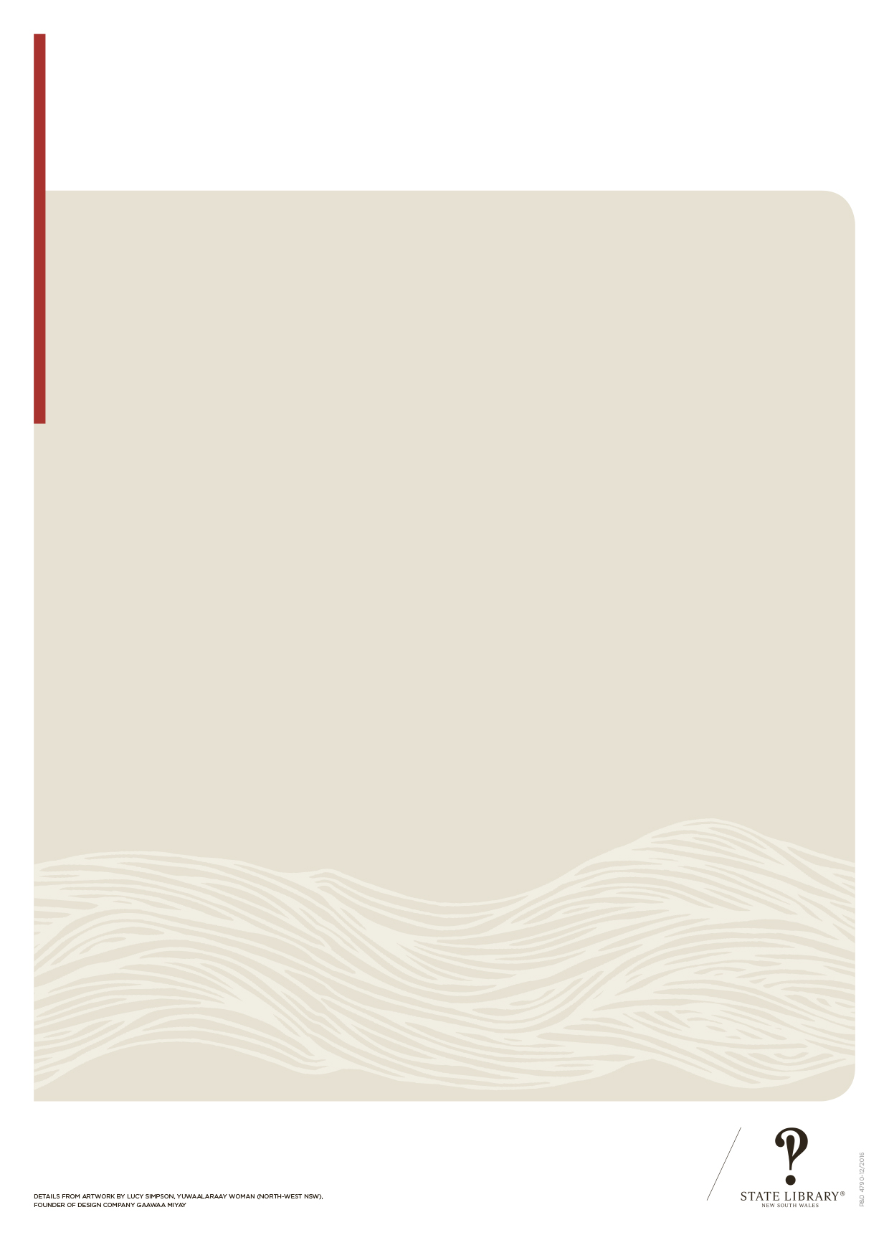
Detail from artwork by Lucy Simpson, Yuwaalaraay woman (north-west NSW),
founder of design company Gaawaa Miyay
INSERT LOCAL COUNCIL LOGO HERE

INSERT LOCAL LIBRARY LOGO HERE

Special care notice

Visitors should be aware that this material may contain images or documentation relating to Aboriginal and
Torres Strait Islander people who are deceased.
Visitors are warned that there may be words and descriptions which may be considered sensitive
and/or offensive in today’s contexts.

